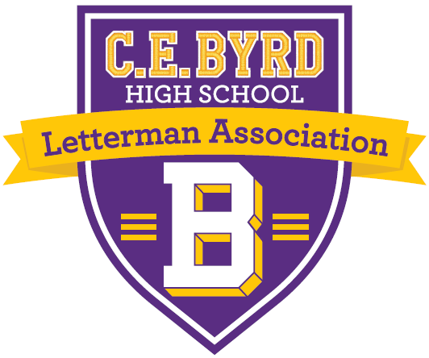

2026 Tournament Committee

AT Emery
(318) 751-0527

Kenneth Favrot
(318) 349-0731

Meredith Duncan
(318) 426-5972

Brian Homza
(318) 470-2719

Email us at byrdhighalumni@gmail.com

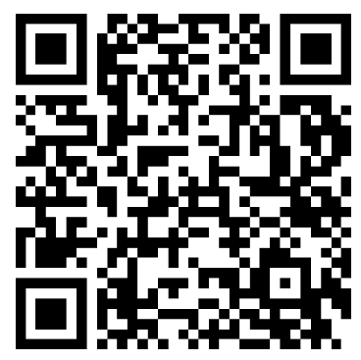
Sign Up Online!

2nd Annual C. E. Byrd Letterman’s Association
GOLF Tournament and Social
Presented by: Hargrove Roofing
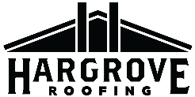

Dear Jacket Alums and Friends:

We are excited to announce the 2nd Annual CE Byrd Alumni Association Golf Tournament to be held at Querbes Golf Course on Friday, June 5, 2026. The event will kick off with a shotgun start at 10:00 am. Lunch will be included along with prizes and goodies!

We are currently looking for sponsors to help support this event. Early sponsorship will help ensure that a realistic budget can be put in place by our planning committee and will ensure that your contribution will be recognized by all who are in attendance. All sponsors will be recognized on our sign-up website, along with a banner that will be displayed at check-in and at the awards reception.

Sponsorship Menu:
General Sponsor: All Gift amounts accepted and appreciated
Cart Path Sponsor $200 (Sign along the cart path)
Purple & Gold Hole Sponsor: $500 (Exclusively sponsor a hole)
Hole in One Sponsor: $1,500 (Sponsor the main prize hole)
Golf Cart Sponsorship: $2,500 (Logo on window of every cart)
Gear Sponsor: $3,000 (Logo on featured gear given to all)
Overall Tournament Sponsor $5,000 (includes recognition and a team)

If your company has merchandise that they would like to add as tee gifts (120 count) or if you would like to donate prizes for the awards ceremony drawing, please reach out to someone on the tournament committee.

You can sign up for any of these sponsorships by using the QR Code on this page or by mailing a check to:

CE Byrd High Alumni Association
c/o Golf Tournament Committee
3201 Line Ave
Shreveport, LA 71104

**Make sure to include the attached form along with your check

2026 Tournament Committee

AT Emery
(318) 751-0527

Kenneth Favrot
(318) 349-0731

Meredith Duncan
(318) 426-5972

Brian Homza
(318) 470-2719

Email us at byrdhighalumni@gmail.com

Sign Up Online!

2026 CE Byrd Alumni Association Golf Sponsorship Form
Friday, June 5, 2026
Shotgun Start 10 am
Querbes Golf Course

Category Amount Included

General Sponsor: $__________________
All Gift amounts accepted and appreciated

Cart Path Sponsor: $__________________ $200 (Sign placed on cart path along with others of this category)

Purple and Gold Hole Sponsor: $__________________
$500 (Exclusive sign at a tee box)

Hole in One Sponsor: $__________________
$1,500 (Sponsor the main prize hole)

Golf Cart Sponsor: $__________________
$2,500 (Logo in window of every cart)

Gear Sponsor: $__________________
$3,000 (Logo on featured gear given to all 120 players)

Overall Tournament Sponsor: $__________________
$5,000 (Recognition, entry for a Golf team of 4 players)

Make Checks Payable to CE Byrd Alumni Association and state in the Memo your desired sponsorship category:

CE Byrd High Alumni Association
c/o Golf Tournament Committee
3201 Line Ave
Shreveport, LA 71104

Your Information:
Name________________________________
Company Name________________________
Contact Phone #________________________
Email_________________________________

*We will reach out to you to get your company logo and information to be included on the sponsorship material.

