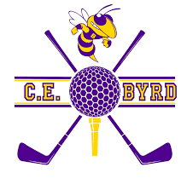

2023-2024 Tournament Committee

AT Emery
(318) 751-0527

Kenneth Favrot
(318) 349-0731

Meredith Duncan
(318) 426-5972

Justin Sevier
(318) 464-1684

Email us at byrdhighalumni@gmail.com

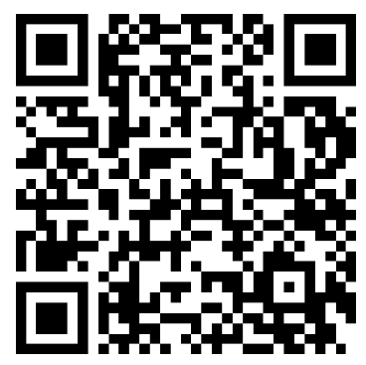
Sign Up Online!

2nd Annual C. E. Byrd High School Alumni Association
GOLF Tournament and Social
Presented by: The Letterman’s Association
3201 Line Ave
Shreveport, LA 71104

Dear Jacket Alums and Friends:

We are excited to announce the 2nd Annual CE Byrd Alumni Association Golf Tournament to be held at Querbes Golf Course on Friday, June 5, 2026, as part of the Byrd Centennial Celebrations! The event will kick off with a shotgun start at 9:00 am. Lunch will be included along with prizes and goodies!

We are currently looking for sponsors to help support this event. Early sponsorship will help ensure that a realistic budget can be put in place by our planning committee and will ensure that your contribution will be recognized by all who are in attendance. All sponsors will be recognized on our sign-up website, along with a banner that will be displayed at check-in and at the awards reception.

Sponsorship Menu:
General Sponsor: All Gift amounts accepted and appreciated
Cart Path Sponsor $200 (Sign along the cart path)
Purple & Gold Hole Sponsor: $500 (Exclusively sponsor a hole)
Gear Sponsor: $1000
Lunch Sponsor: $1500
Tournament Polo Shirt Sponsor: $3,000 (Logo on 120 Golf Shirt)
Overall Tournament Sponsor $5,000 (includes recognition and a team)

If your company has merchandise that they would like to add as tee gifts (120 count) or if you would like to donate prizes for the awards ceremony drawing, please reach out to someone on the tournament committee.

You can sign up for any of these sponsorships by using the QR Code on this page or by mailing a check to:

CE Byrd High Alumni Association
c/o Golf Tournament Committee
3201 Line Ave
Shreveport, LA 71104

**Make sure to include the attached form along with your check

We look forward to your involvement not only in sponsorship, but also in the camaraderie of the golf tournament. If you have any questions please call us at the numbers listed or email us at byrdhighalumni@gmail.com

2023-2024 Tournament Committee

AT Emery
(318) 751-0527

Kenneth Favrot
(318) 349-0731

Meredith Duncan
(318) 426-5972

Email us at byrdhighalumni@gmail.com

Sign Up Online!

2026 CE Byrd Alumni Association Golf Sponsorship Form
Friday, June 5, 2026
Shotgun Start 9 am
Querbes Golf Course

Category Amount Included

General Sponsor: $__________________
All Gift amounts accepted and appreciated

Cart Path Sponsor: $__________________ $200 (Sign placed on cart path along with others of this category)

Purple and Gold Hole Sponsor: $__________________
$500 (Exclusive sign at a tee box)

Tournament Polo Shirt Sponsor: $__________________
$3,000 (Logo on 120 Golf Shirt)

Overall Tournament Sponsor: $__________________
$5,000 (Recognition, entry for a Golf team of 4 players)

Make Checks Payable to CE Byrd Alumni Association and state in the Memo your desired sponsorship category:

CE Byrd High Alumni Association
c/o Golf Tournament Committee
3201 Line Ave
Shreveport, LA 71104

Your Information:
Name________________________________
Company Name________________________
Contact Phone #________________________
Email_________________________________

*We will reach out to you to get your company logo and information to be included on the sponsorship material.

